Digital Electronics

See Boolean Algebra for a description of the category as well as references.

NAME | GRAPHICAL SYMBOL | ALGEBRAIC EQN | TRUTH TABLE
BUFFER | 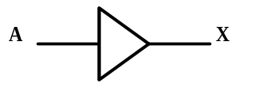 | X = A | A X  0 0  1 1
NOT | 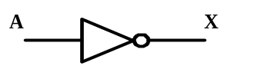 | X = 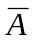 | A X  0 1  1 0
AND | 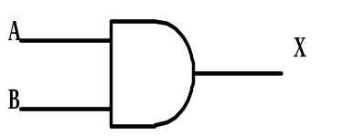 | X = AB or A*B | A B X  0 0 0  0 1 0  1 0 0  1 1 1
NAND | 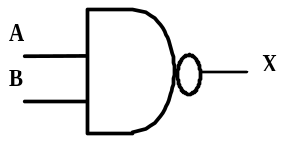 | X = 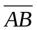 or 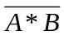 | A B X  0 0 1  0 1 1  1 0 1  1 1 0
OR | 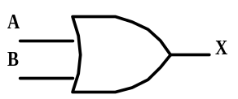 | X = A+B | A B X  0 0 0  0 1 1  1 0 1  1 1 1
NOR | 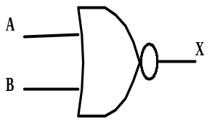 | X = 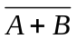 | A B X  0 0 1  0 1 0  1 0 0  1 1 0
EXCLUSIVE-OR  (XOR) | 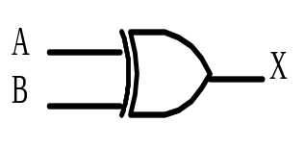 | X = A⊕B | A B X  0 0 0  0 1 1  1 0 1  1 1 0
EQUIVALENCE  (XNOR) | 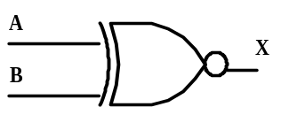 | X = 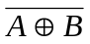 | A B X  0 0 1  0 1 0  1 0 0  1 1 1

Sample Problems

Find all ordered 4-tuples (A, B, C, D), which make the following circuit FALSE:

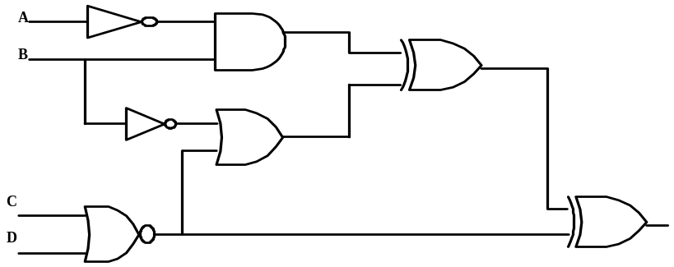

The circuit translates to the following Boolean expression:

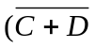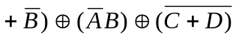

The following table has the following headings: H1 is 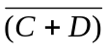, H2 is H1+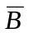, H3 is B, H4 is H2⊕H3 and H5 is H4⊕H1, the final expression.

A | B | C | D | H1 | H2 | H3 | H4 | H5
0 | 0 | 0 | 0 | 1 | 1 | 0 | 1 | 0
0 | 0 | 0 | 1 | 0 | 1 | 0 | 1 | 1
0 | 0 | 1 | 0 | 0 | 1 | 0 | 1 | 1
0 | 0 | 1 | 1 | 0 | 1 | 0 | 1 | 1
0 | 1 | 0 | 0 | 1 | 1 | 1 | 0 | 1
0 | 1 | 0 | 1 | 0 | 0 | 1 | 1 | 1
0 | 1 | 1 | 0 | 0 | 0 | 1 | 1 | 1
0 | 1 | 1 | 1 | 0 | 0 | 1 | 1 | 1
1 | 0 | 0 | 0 | 1 | 1 | 0 | 1 | 0
1 | 0 | 0 | 1 | 0 | 1 | 0 | 1 | 1
1 | 0 | 1 | 0 | 0 | 1 | 0 | 1 | 1
1 | 0 | 1 | 1 | 0 | 1 | 0 | 1 | 1
1 | 1 | 0 | 0 | 1 | 1 | 0 | 1 | 0
1 | 1 | 0 | 1 | 0 | 0 | 0 | 0 | 0
1 | 1 | 1 | 0 | 0 | 0 | 0 | 0 | 0
1 | 1 | 1 | 1 | 0 | 0 | 0 | 0 | 0

Thus, the 4-tuples (0,0,0,0), (1,0,0,0), (1,1,0,0), (1,1,0,1), (1,1,1,0), and (1,1,1,1) all make the circuit FALSE.

Find all ordered triplets (A, B, C) which make the
The circuit translates to the following Boolean expression: 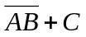. To find when this is FALSE we can equivalently find when the 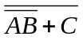 is TRUE. We can simplify this by applying DeMorgan’s Law and cancelling the double not over AB to yield 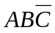. This is TRUE when all three terms are TRUE, which happens for (1, 1, 0).
following circuit FALSE:
